# SUMMARY DOCUMENT

# REVISED MIDDLE HEAD / GUBBUH GUBBUH

# DRAFT MASTER PLAN AUGUST 2023

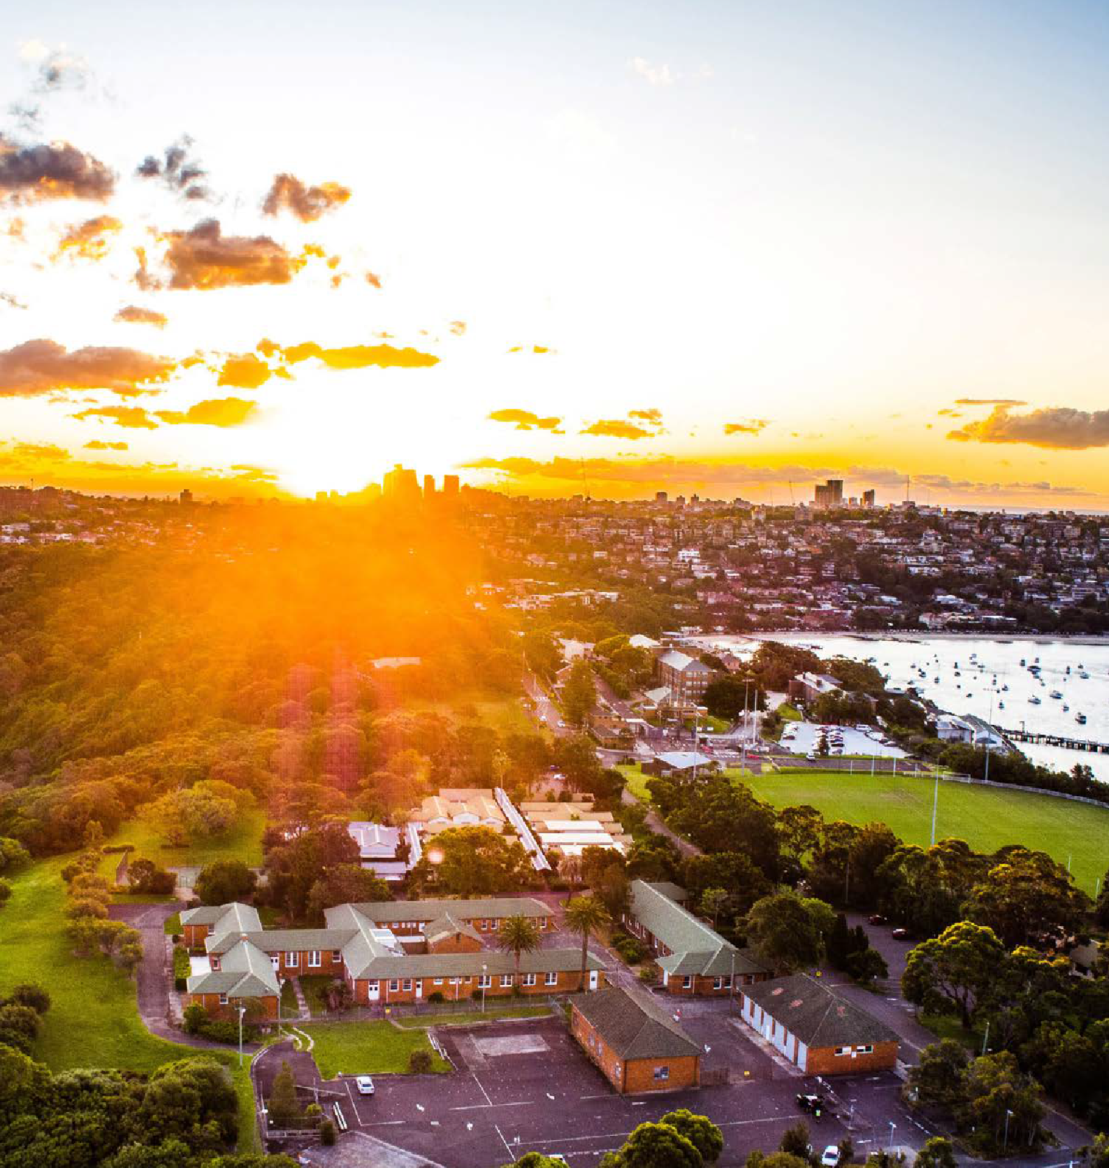



# CONTENTS

1. INTRODUCTION

1.1 An overview of Middle Head / Gubbuh Gubbuh

1.2 The vision and values that underpin the revised draft master plan

1.3 About the revised draft master plan

1.4 Statutory framework and the role of the master plan

2. WHERE WE ARE NOW

2.1 Timeline of what has been done and where we are now

2.2 Outcomes from initial consultation

3. PROPOSED KEY ACTIONS WITHIN THE REVISED DRAFT MASTER PLAN

3.1 Enhance and protect the natural environment

3.2 Create a walking place

3.3 Share history and stories of place

3.4 Create new open spaces and public domain

3.5 Adaptive re-use and renewal of heritage buildings

3.6 Breathe life into the headland

3.7 Support visitors getting to and from the headland

3.8 Upgrade facilities and keep Middle Head Oval as is

4. NEXT STEPS IN THE PROCESS AND DELIVERY PLAN

5. HAVE YOUR SAY

<pp> 1

# ACKNOWLEDGEMENT OF COUNTRY

The Harbour Trust acknowledges the Traditional Custodians and Owners of the lands, waters, and sky of Sydney Harbour, including the places under our stewardship. We respectfully acknowledge the Traditional Owners of Sydney Harbour, including those belonging to the Borogegal, Birrabirrigal, Cammeraygal, Gadigal, Gayamagal, Wallumedegal and Wangal clans.

We acknowledge this Country, now known as Gubbuh Gubbuh, the custodianship of its people, and the ongoing connection to culture, lands and waters. We pay our respects to all surrounding clans of the region and honour their Elders past, present and emerging.

The Project Team recognises we are working within a cultural landscape and understand designing with Country is a privilege that comes with responsibility. We are guided by the inspiration of Country and the knowledge it contains.

<pp> 2

# 1. INTRODUCTION

**Photo caption: Aerial view from Middle Head / Gubbuh Gubbuh looking south-west over Obelisk Beach to the CBD.**

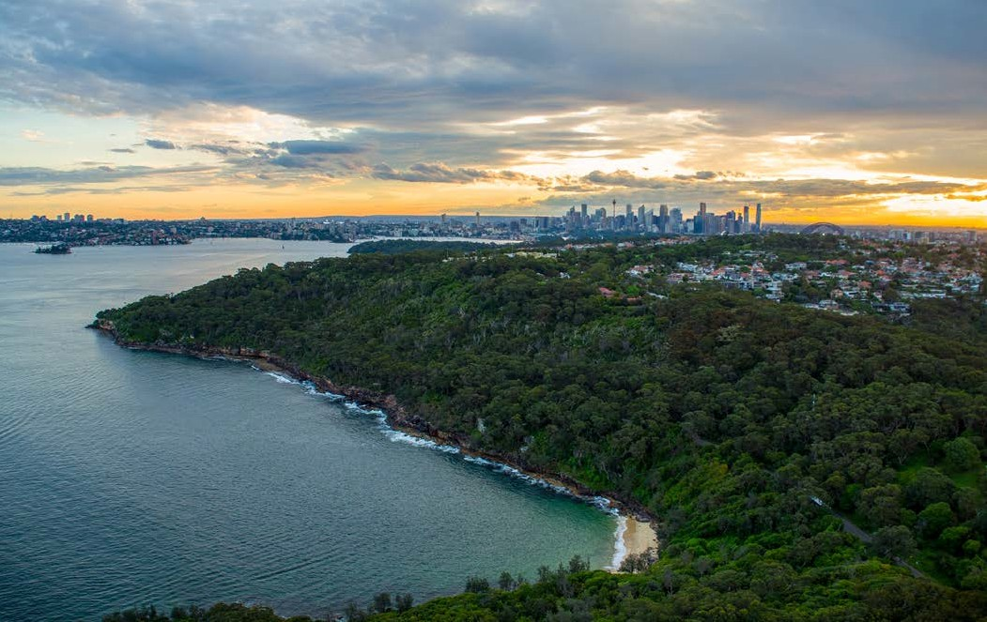

The Harbour Trust's Middle Head / Gubbuh Gubbuh Draft Master Plan was available for initial public comment from 14 March - 9 May 2023.

Following this consultation and review of comments and community feedback, the Harbour Trust created a revised draft master plan for further public exhibition. This is a summary document of the full revised draft master plan document requested as part of the feedback.

The Middle Head / Gubbuh Gubbuh Draft Master Plan focuses on the area of the headland that's managed by the Harbour Trust. It is a detailed examination of the site's cultural and natural heritage values, its constraints and opportunities and presents the Harbour Trust's long-term vision of place.

The revised draft master plan provides guiding principles for future revitalisation of both the lands and the built assets within the context of the Harbour Trust's Middle Head Management Plan.

|  |
| --- |
| To have your say about the revised draft master plan, visit [www.harbourtrust.gov.au/middle-head-consultation](http://www.harbourtrust.gov.au/middle-head-consultation) and:   * Review this summary of the revised draft master plan * Review the outcomes report from the initial consultation in March 2023 * Review the Revised Middle Head / Gubbuh Gubbuh Draft Master Plan and supporting documents * Provide Feedback, see page 16 for details   Submit feedback by 5pm Thursday 21 September 2023 (AEST) |

<pp> 3

## 1.1 An overview of Middle Head / Gubbuh Gubbuh

Middle Head / Gubbuh Gubbuh is a nationally significant headland in Mosman that overlooks the entrance to Sydney Harbour. The lands have been home to First Nations people for millennia.

In the early days after colonisation, New South Wales used the natural vantage point of Middle Head / Gubbuh Gubbuh for Australia's earliest defensive fortifications.

In both the First World War and Second World War, Middle Head / Gubbuh Gubbuh played a key part in the defence of Sydney and in the rehabilitation of those returning from war.

The Australian School of Pacific Administration (ASOPA) was also located at Middle Head for over 27 years and trained hundreds of personnel for service in Papua New Guinea, Northern Territory and Nauru. The Australian Army maintained a position on Middle Head / Gubbuh Gubbuh until the 1990s and the Royal Australian Navy maintains an active presence on the headland at HMAS *Penguin*.

Middle Head / Gubbuh Gubbuh is now accessible by the public and managed by two statutory agencies, the Harbour Trust, a corporate Commonwealth entity within the Department of Climate Change, Energy, the Environment and Water (DCCEEW); and the NSW National Parks and Wildlife Service (NPWS).

**Photo caption: An aerial photo of Middle Head / Gubbuh Gubbuh, Mosman. The area circled in red shows the Harbour Trust land that's the focus of the draft master plan.**

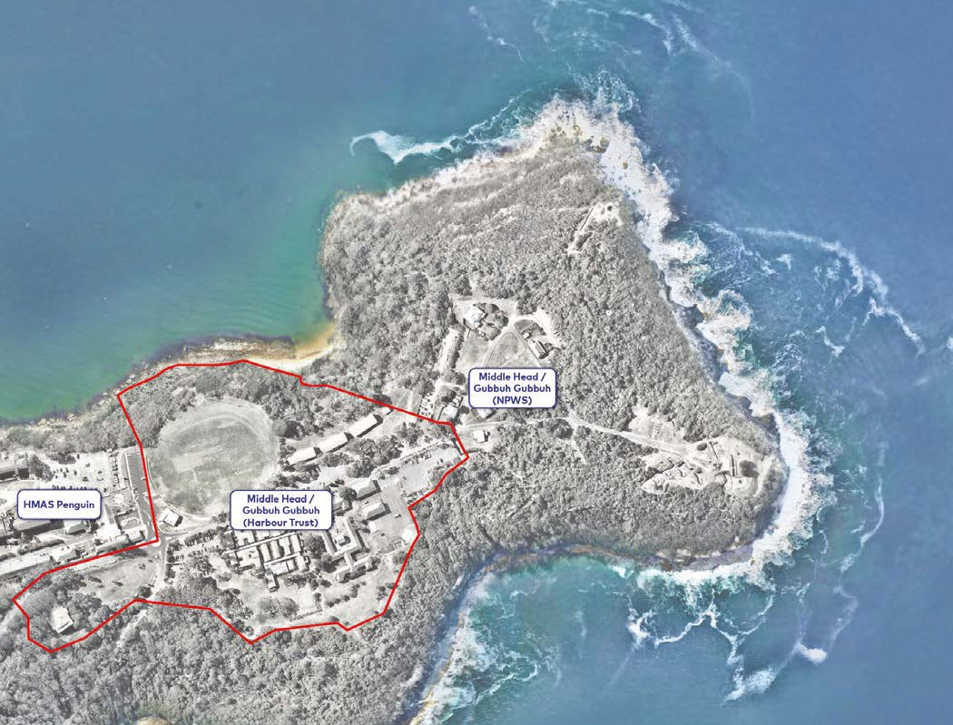

<pp> 4

## 1.2 The vision and values that underpin the revised draft master plan

The Harbour Trust's vision of place for Middle Head / Gubbuh Gubbuh remains unchanged from the initial draft master plan. It sees the headland as a place of:

* Natural sanctuary, sustainability and environmental care
* Enriched public access
* Enshrined memory, immersive learning and interpretation excellence
* Built form and public domain excellence
* Life and vibrancy – a place for people on one of Sydney's finest headlands.

Creating a vision for a place of national significance, such as Middle Head / Gubbuh Gubbuh, requires the area's key values to be examined, elevated, understood and documented.

The inherent cultural heritage values of Middle Head / Gubbuh Gubbuh can be described under three main areas: First Nations heritage; military and colonial heritage; natural heritage.

Within the revised draft master plan, the key values of place have guided the Harbour Trust's proposed key actions and one value is never put above another – they need to be considered collectively to tell the full story of place.

The revised draft master plan explores the key cultural heritage values of Middle Head / Gubbuh Gubbuh in detail.

The vision, values and key actions within the revised draft master plan are interrelated.

## 1.3 About the revised draft master plan

Generally, the Harbour Trust defines a master plan as two things. It involves:

* Robust analysis of an area to establish key constraints and opportunities
* The preparation of a design response that carefully references and responds to the above analysis.

The design response helps ensure a coordinated approach to future renewal and is underpinned by a set of key actions and guiding principles. Key actions are further supported by design and delivery strategies. In short, a master plan puts forward a future vision of place.

Revisions that have been made to the initial draft master plan have been based on many factors, including feedback from initial public exhibition, alignment with Harbour Trust objectives and the vision for the headland.

Key actions updated in the revised draft master plan are:

* No change to the oval is proposed
* Middle Head Oval changing facilities to remain in current location and be upgraded
* No change to existing roundabout
* Guard House/café building retained with car parking
* Clarification on proposed activations and events
* Amendments to proposed extent of car parking and bus drop-off.

<pp> 5

## 1.4 Statutory framework and the role of the master plan

The planning context which the revised draft master plan sits within is shown in the table below.

The Comprehensive Plan and the 2017 Middle Head Management Plan are statutory plans which have informed the preparation of the draft master plan. The master plan provides design guidance for future proposals in the precinct. Proposals for implementation must be consistent with the statutory plans, and are subject to the detailed planning approval stage. Detailed proposals will be made available for further public consultation.

### Harbour Trust Planning Framework



<Transcriber's Note>

The Flowchart above shows Statutory Processes – All site and Management Processes.

**Statutory Processes**

Environment Protection and Biodiversity Conservation Act 1999 [arrow down to]

* **2017 Middle Head Management Plan** (In accordance with the Comprehensive Plan and the EPBC Act) [Arrow down to]
* Planning Permits and Approvals (In accordance with the SHFT Act and Regulations, and EPBC Act)

Sydney Harbour Federation Trust Act 2001 [arrow down to]

* **Comprehensive Plan** (In accordance with Part 5 of the SHFT Act) [arrow down to]
* **2017 Middle Head Management Plan** (In accordance with the Comprehensive Plan and the EPBC Act) [Arrow down to]
* Planning Permits and Approvals (In accordance with the SHFT Act and Regulations, and EPBC Act)

**Management Processes**

**Comprehensive Plan** and **2017 Middle Head Management Plan** have arrows across to Management processes:

* Master Plan (Middle Head / Gubbuh Gubbuh)

</Transcriber's Note>

<pp> 6

### Supporting Document

The following documents have been used to inform the development of the revised draft master plan and can be accessed on the Have Your Say webpage at [www.harbourtrust.gov.au/middle-head-consultation](http://www.harbourtrust.gov.au/middle-head-consultation)

* Initial Consultation Outcomes Report
* Revised Master Draft Plan
* Transport and Access Management Plan
* Expert Advice Review Paper: Removal of Timber Buildings
* Timber Buildings Structural Assessment Report
* Timber Buildings Bushfire Assessment
* Timber Buildings BCA Assessment
* Timber Buildings Heritage Assessment – Supplementary Report
* Timber Buildings Heritage Assessment – Updated
* Timber Buildings Comparative Study
* Ecological Constraints Assessment

<pp> 7

# 2. WHERE WE ARE NOW

## 2.1 Timeline of what has been done and where we are now

* **2019 & 2020:** **COMMONWEALTH FUNDING ANNOUNCED TO HARBOUR TRUST**The Australian Government announced funding for the Middle Head / Gubbuh Gubbuh precinct.
* **Sept 2020: MIDDLE HEAD / GUBBUH GUBBUH PROJECT DIRECTION DEVELOPED**Project scoping and input from the Harbour Trust Community Advisory Committee and Aboriginal and Torres Strait Islander Advisory Committee.
* **Nov 2020: PUBLIC CONSULTATION – PROJECT DIRECTION**Public exhibition of the Project Direction.
* **Mar 2021: CONSULTATION OUTCOMES REPORT – PROJECT DIRECTION**Summary of feedback prepared by the Harbour Trust.
* **Mar 2021: PRELIMINARY SAFETY WORKS**Safety works to remove hazardous materials from the heritage buildings.
* **Late 2021: FIRST NATIONS GUIDING PRINCIPLES DEVELOPED**The Harbour Trust works with First Nations community members to create a set of principles that help embed Country into everything we do as an organisation.
* **Feb-Sept 2022: HERITAGE CONSERVATION WORKS**Critical works to ensure long-term weather protection of the heritage fabric of Buildings 1 and 3. Works comprised roof structure repairs and tile replacement; replacement of flashings and guttering in copper; reconstruction of all eaves; renovation of timber windows; brickwork repointing and stabilisation.
* **Mar-May 2023: PUBLIC CONSULTATION – DRAFT MASTER PLAN**Initial draft master plan open for public comment.
* **Jun 2023: CONSULTATION OUTCOMES REPORT – DRAFT MASTER PLAN**Consultation Outcomes Report finalised.
* **Aug 2023 We are here: PUBLIC CONSULTATION – REVISED DRAFT MASTER PLAN**Revised draft master plan open for public comment.

See page 15 for next steps in the process

<pp> 8

## 2.2 Outcomes from initial consultation

From 14 March until 9 May 2023, the Harbour Trust's Middle Head / Gubbuh Gubbuh Draft Master Plan was on public exhibition. The aim of this public exhibition was to receive initial feedback to inform the creation of a revised draft master plan.

The Harbour Trust reviewed all feedback received during the initial exhibition and created a [Consultation Outcomes Report](https://www.harbourtrust.gov.au/media/xkyfu2n5/middle-head-draft-master-plan_consultation-outcomes-report.pdf). This report provided an overview of the key themes raised, the Harbour Trust's response to them and how they have now been addressed in the revised draft master plan.

**Key themes raised during initial consultation of draft master plan**

### BASED ON CONSULTATION OUTCOMES REPORT

| **SUPPORT FOR** | **CONCERNS ABOUT** |
| --- | --- |
| * The importance of having a documented draft master plan that provides a vision for the headland. * New and improved walking tracks * An Interpretation Centre that explores all key values and layered history associated to the headland * The preservation and adaptive reuse of the 10 terminal brick barracks precinct * Bushland protection and regeneration * A range of feedback was provided regarding proposed removal of the timber buildings – with support and concerns both raised | * Removal of the Guard House/relocation of café * Relocation of Middle Head Oval changing facilities and reconfiguration of oval * Types and scales of events * Traffic impacts * A range of feedback was provided regarding proposed removal of the timber buildings – with support and concerns both raised |

|  |
| --- |
| **Harbour Trust response/key aspects updated in the revised draft master plan**   * **Middle Head Oval** No change to Middle Head Oval * **Roundabout** No change to existing roundabout * **Middle Head Oval changing facilities** To remain in current location and ne upgraded * **Guard House/café building** Retained with car parking * **Car parking** Amendments to proposed extent of car parking |

<pp> 9

# 3. PROPOSED KEY ACTIONS WITHIN THE REVISED DRAFT MASTER PLAN

**Photo caption: This image provides a snapshot of the proposed key actions, as presented in the revised draft master plan. These actions are covered further in this section of the summary document.**

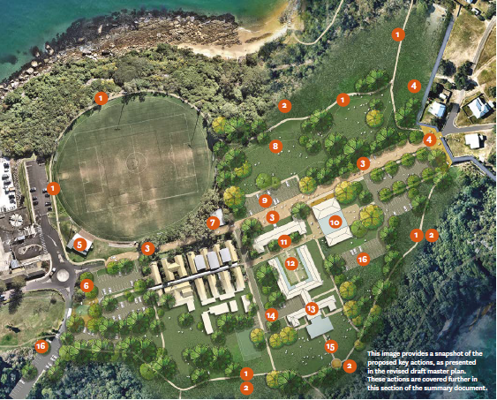

<Transcriber's Note>

Aerial View of the Middle Harbour site with the harbour at the top left of the photo. The oval is shown on the left below the harbour and a section of bushland. To the far left of the oval is a carpark connected to another car park at the front of the photo by a roundabout. Labels 1 and 2 are in several places around the boundary of the site. 3 is a long path from the roundabout through the area to 4 (existing depot) on the far right of the site. 5 (changing facilities) are attached to the oval near the roundabout. On the adjacent corner of the roundabout is 6. At the bottom right of the oval is 7 (existing Guard house and café). To the right of 7 is 9 (former parade ground. Above this is 8.

The area in the middle right of the site contains the building mentioned in 10, 11, 12 and 13. Around building mentioned in 12 and 13 are the areas 14 and 15.

On the lower right of the site is 16.

</Transcriber's Note>

The proposed key actions within the revised draft master plan will help the Harbour Trust deliver on its vision of place for Middle Head / Gubbuh Gubbuh. Section 3 explores the proposed key actions within the revised draft master plan.

1. Create plateau walk and headland loop. Adjacent the oval the path is to be located on the harbour side of the existing fence. No change to the oval is proposed.
2. Rehabilitate the ecologically sensitive bushland margin zones.
3. Create shared zone and main site pedestrian spine.
4. Examine removal of existing depot and structures to reveal historic defensive ditch fortifications.
5. Upgrade changing facilities.
6. Examine bus turning adjacent to the existing roundabout.
7. Guard House/café building – no change proposed.
8. Removal of existing structures to create natural public domain with curated First Nations walk and outlook to the harbour.
9. Examine and interpret former parade ground. Enable car parking and multi function use of area.
10. Establish Interpretation Centre.
11. Conservation and adaptive reuse of Brick Barracks Buildings 1 and 3. Adopt a highly sensitive architectural material palette.
12. Establish courtyard as activated public domain.
13. Establish distinctive food and beverage facility with southern harbour view terrace.
14. Activate the southern lawn and terrace.
15. Rehabilitate the ecologically-sensitive landscape margin zones.
16. Reconfigure car parking hardstand areas as permeable paved zones.

<pp> 10

## 3.1 Enhance and protect the natural environment

The sheer beauty of the headland's natural bushland vegetation along the northern and southern boundaries is an important remnant of the original plant communities that once covered much of Sydney's coast.

Some areas of Middle Head / Gubbuh Gubbuh bushland are in poor condition due to previous landfill activity, changes in drainage patterns, increased soil nutrient levels and the absence of fire. Increased storm water run-off and increased nutrient levels have resulted in moderate to severe weed invasion around the edges. To protect and conserve the natural ecological and scenic values of the bushland vegetation, the Harbour Trust will:

* Give priority to bushcare programs that protect rare, vulnerable and endangered plant species and communities from disturbance and manage them in a way that will ensure their long-term conservation
* Increase the amount of vegetated land within the master plan area by re-vegetating and re-generating areas that are currently degraded or where buildings, paving or fill have been removed, in a manner compatible with bushfire protection
* Integrate bushcare programs with management practices and programs of neighbours, local councils, fire authorities and adjoining land managers.

**Photo caption: Middle Head / Gubbuh Gubbuh from above and surrounding lands, water and sky**

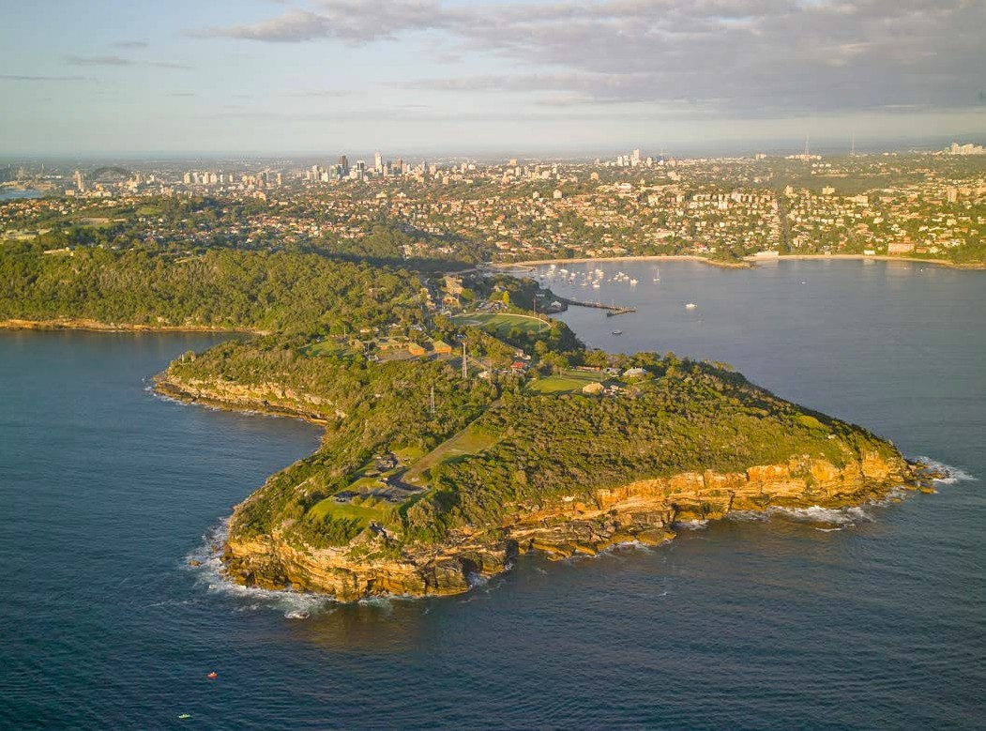<pp> 11

## 3.2 Create a walking place

Middle Head / Gubbuh Gubbuh is a place of quiet reprieve from the hustle and bustle of Sydney and offers numerous walking tracks. To complement existing tracks, NPWS is constructing new sections of walking tracks that better integrates the headland with existing coastal walks including the Bondi to Manly 80km walk.

Within the revised draft master plan, the Harbour Trust seeks to elevate the potential for the headland to be a place to walk, reflect, learn and to enjoy. This includes the:

* Completion of a headland loop walking track with NPWS, a spectacular new iconic walk for Sydney
* Creation of a plateau circuit path on Harbour Trust land that will be accessible for people of all abilities
* Creation of a primary pedestrian spine and simple network of movement that connects the site to create a singular memorable place.

Elevating on-foot connections will be done in a considered way that factors in constraints of the area, such as transport access and the need for car parking.

Additionally, the Harbour Trust and NPWS are working together to ensure that the network of paths at Middle Head / Gubbuh Gubbuh are coordinated and connected.

The new paths will be modest and designed in sympathy with the place's natural and heritage values. The path around the oval would be approximately 2 metres wide, outside the playing field and would not impact any natural bushland, or the playing area of Middle Head Oval.

## 3.3 Share history and stories of place

Meaningful interpretation activities are an important way to share the history and stories of Middle Head / Gubbuh Gubbuh and to achieve positive visitor experiences.

Within the draft master plan, the key to public interpretation is the establishment of a physical presence. The Interpretation Centre, proposed to be housed within the Garage Buildings (Buildings 6 and 7), will fulfill this purpose – sharing history and stories and providing a physical place of meaning to the First Nations, military and natural heritage values of the site. The history of ASOPA and its significance for Australia's involvement in Papua New Guinea and the Pacific will also be included within the Interpretation Centre.

The proposed Interpretation Centre is geographically "centred" within the headland, creating a natural focal point to the overall headland visitor experience.

The Garage Buildings offer the space and internal height to support contemporary display services (such as lighting and communications systems) including larger format audio visual displays. It could also be home to other offerings such as a café, community meeting spaces and public amenities.

To complement the Interpretation Centre, a range of supporting activities are proposed to engage visitors, enrich their experience and share the history and stories of the headland. These include, but are not limited to:

* High-quality and flexible public exhibition spaces within the Garage Buildings (Buildings 6 and 7)
* Guided tours (possibly in conjunction with NPWS)
* Cultural events and open days held in conjunction with NPWS
* Interpretive signage
* Public programs
* Recording, archiving and presentation of audio stories.

|  |
| --- |
| What is Interpretation? Interpretation is an overarching term to describe activities that help people engage and make valuable connections with what’s around them. Exhibitions, guided walks, audio tours and interactive signage are a few examples of interpretation activity. Such activity can entertain, broaden views, promote curiosity, create meaning and provoke thought. |

<pp> 12

**Photo caption: View from Middle Head / Gubbuh Gubbuh looking northwest towards Balmoral Beach and beyond.**

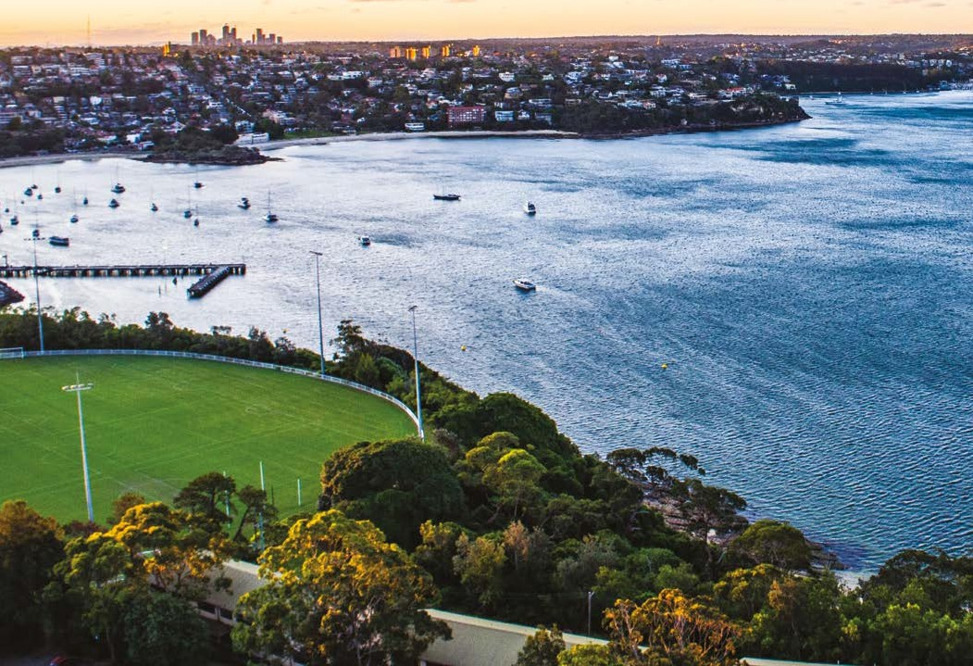

## 3.4 Create new open spaces and public domain

The Harbour Trust’s longstanding position is to enable the creation of valuable new community parkland, greater connections to NPWS lands and walking tracks for passive recreational enjoyment.

One of the proposed actions in creating new open space is the removal of the timber buildings.

Following the initial draft master plan consultation, the Harbour Trust commissioned a review report to provide an independent opinion on the proposal to removal of the timber buildings. This review broadly addresses statutory documentation, relevant heritage studies and reports into the precinct and timber buildings, archaeological reports in relation to the zone and immediate surrounds to the subject buildings and the Revised Draft Master plan.

This review report supports the proposal to remove the timber buildings.

<pp> 13

**Photo caption: Aerial photo of brick barracks, ASOPA and parklands on the south side of the precinct.**

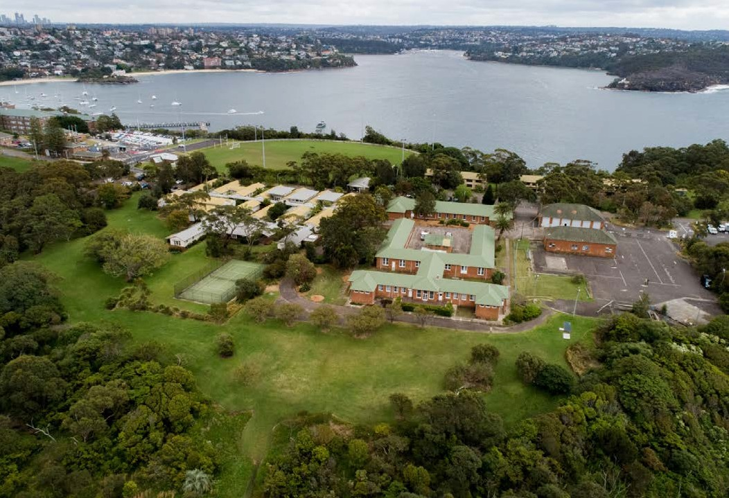

## 3.5 Adaptive re-use and renewal of heritage buildings

The draft master plan proposes the heritage listed brick barracks on the south side of Middle Head Road (Buildings 1 and 3) will be adaptively reused in a way that allows for the conservation and interpretation of their heritage values.

Conservation works to the buildings has already commenced, with new roofing, copper guttering and reinstatement of windows undertaken in 2022.

The appropriate uses considered by the Harbour Trust for these building includes food and beverage, dining, functions, offices, studios, education, well-being, cultural activities and small scale retail. The adaptive reuse of the site will ensure ongoing public access and enhance the visitor experience to the headland.

A "light touch" will be applied to the heritage Garage Buildings (Buildings 6 and 7), which will become the proposed Interpretation Centre, resulting in a newly created linked space. To ensure this adaptive reuse treads lightly, the space will be bound by glazed elements to not impose upon the surroundings. This linking space will subtly unite the two buildings, allowing for various activities to occur between them.

The Guard House/café will remain in place for years to come, but its retention will be reviewed in the long term, consistent with the [**Middle Head Management Plan**.](https://www.harbourtrust.gov.au/media/1375/hpmiddle-head-management-plan.pdf)

<pp> 14

## 3.6 Breathe life into the headland

Experiences through activations and events animate places and enable the Harbour Trust to share and listen to stories, grow connections, advocacy and investment in our vision and purpose. The Harbour Trust plans to ensure experiences at Middle Head / Gubbuh Gubbuh:

* Respond to the needs of local communities, diverse audiences, and new markets
* Are developed and delivered to respond to the expectations of contemporary audiences
* Build connections to the sites for generations to come.

There is no intention to create a purpose-made venue for large-scale events at Middle Head / Gubbuh Gubbuh.

Instead, the proposal within the revised draft master plan is that the open parkland of Middle Head / Gubbuh Gubbuh would be used no more than twice a year for events such as heritage open days, temporary exhibitions or performances, community festivals and First Nations gatherings. Such events would be within the capacity of the site, including traffic, parking and noise considerations. If required, specific traffic plans would be prepared for events, to ensure appropriate measures are put in place to minimise traffic impacts.

The revised draft master plan has clarified the Harbour Trust's considered approach to events on the headland, including providing explanation on visitor numbers.

It is proposed these two events would be capped at a maximum of 500 people at any one time. An example of this might be a bushcare open day – where a cumulative 2,000 people may attend over the course of a weekend.

Food and beverage offerings can also bring a sense of vibrancy to Middle Head / Gubbuh Gubbuh.

## 3.7 Support visitors getting to and from the headland

Middle Head / Gubbuh Gubbuh has limitations in terms of access and parking. Therefore, recognising the key constraints – combined with identifying the right balance of accommodating growth associated with activation and enhancing public access and amenity – are key elements for consideration within the revised draft master plan. The revised draft master plan proposes:

* To reduce the carparking hardstand to the east of Building 7 (one of the Garage Buildings)
* Create additional carparking capacity to the west and south of the ASOPA complex
* Limited reconfiguration of Middle Head Road, to allow for the creation of a pedestrian friendly shared zone.

Both the initial and the revised draft master plans have been informed by a Transport and Access Management Plan (TAMP). For the revised draft master plan, the TAMP has been updated and made available as part of the re-exhibition process.

## 3.8 Upgrade facilities and keep Middle Head Oval as is

As it relates to Middle Head Oval, the Harbour Trust collaborated with Mosman Council to explore potential new locations for replacement changing facilities, but none of these were viable. The revised draft master plan proposes that the oval's changing facilities remain in its current location, and that it will be upgraded to improve the facilities. Middle Head Oval will remain unchanged. There will be no reduction in its playing space, nor any reorientation of playing fields.

<pp> 15

# 4. NEXT STEPS IN THE PROCESS AND DELIVERY PLAN

* **2022 TO 2023:  
  CONSERVATION WORKS AND MASTER PLANNING**Preservation works to Buildings 1 and 3
* Structural restoration
* New roofing and guttering
* Window restoration
* Fire and compliance works
* **Aug 2023 We are here:  
  MASTER PLANNING AND COMMUNITY CONSULTATION**Public exhibition of the revised draft master plan
* **Late 2023:  
  FINAL MASTER PLAN**
* Consultation outcomes report published
* Adoption of draft master plan considered by Members of the Trust
* **Late 2023 to Mid 2024:  
  DESIGN AND STAGE 1 PROCUREMENT  
  SITE INVESTIGATIONS DESIGN**
  + - Design developed for stage 1 and future stages
    - Public exhibition of development application

**FINAL DESIGN**

**PROCUREMENT OF STAGE 1 WORKS**

* Tendering and procurement
* **Mid 2024 to Mid 2025:  
  STAGE 1 WORKS**
* Adapt Buildings 1 and 3 for leasing opportunities
* Removal of timber buildings and replacement into parkland
* Create headland loop path
* Conservation works to Garage Buildings (Buildings 6 and 7) to enable meanwhile use for exhibitions and community groups
* Deliver immersive digital visitor experience
* Site services infrastructure
* **Following completion of stage 1:  
  LEASING EOI**Leasing EOI on Buildings 1 and 3
* **Subject to funding availability:  
  FUTURE STAGED WORKS**
* Adapt and connect Garage Buildings (Buildings 6 and 7) for Interpretation Centre
* Interpretation programming strategy
* Parade ground works
* Car parking works

<pp> 16

# 5. HAVE YOUR SAY

To have your say about the revised draft master plan, visit [www.harbourtrust.gov.au/middle-head-consultation](http://www.harbourtrust.gov.au/middle-head-consultation) to provide your feedback online.

Submit your feedback by 5pm Thursday 21 September 2023 (AEST)

<pp> 17

**Harbour Trust**

Building 28, Best Avenue  
Mosman NSW 2088

[**harbourtrust.gov.au**](http://harbourtrust.gov.au/)